**Abcedi Ilacas**

**138180211**

**25/01/2024**

**Lab 04**

**1)**

**ANSI-89**

**ANSI-92**

**2)**

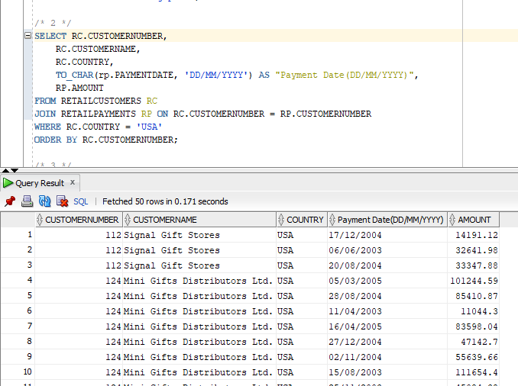

**3)**

**4)**

**5)**

**6)**

**7)**

**8)**

**9)**

**10)**

